Lab 1: C Programming

Introduction
In this lab you will learn to program the MIPS processor in C. You will first complete a tutorial on writing, compiling, and downloading an example C program. Then you will write your own C program to calculate the Fibonacci numbers.

MIPS C Tutorial
The MIPS processor is programmed using Codescape compiler tools. Codescape supports programming in both C and assembly language.
In this tutorial, you will learn to write and compile a simple program that reads the value of the switches on the FPGA board and flashes their values to the LEDs.

Example C Program
Before writing your own program, we walk you through the steps of compiling, and running a program using some example code. Browse to this directory:
MIPS_Labs\Lab_1\C\ReadSwitches
Open the file main.c using a text editor such as Notepad or Wordpad. The main.c file contains the ReadSwitches program, as shown in Figure 1.

#include "mfp_io.h"

void delay();

//------------------
// main()
//------------------
int main() {
volatile unsigned int switches;

while (1) {
switches = MFP_SWITCHES;

MFP_7SEGEN = 0; // turnon all 7-segment displays

MFP_LEDS = switches; // turnon LEDS
MFP_7SEGDIGITS = switches;

delay();
MFP_7SEGEN = 0x3f ; // turn off all 7-segment displays
MFP_LEDS = 0; // turn off LEDs
delay();
}
return 0;
}

void delay() {
volatile unsigned int j;

for (j = 0; j < (900000); j++) ; // delay
}

Compiling, Running, and Debugging
Now compile, and run the ReadSwitches example C program on the MIPS core using the following steps, described in detail below.
Step 1. Download the MIPS system onto the FPGA board
Step 2. Compile the C program
Step 3. Load the C program onto MIPS using UART

Step 1. Download the MIPS system to the FPGA board
First, you will download the MIPS system onto the FPGA board. To do so, connect the FPGA board to your computer, turn the board on, and open Adept. Click Browse button (see Figure 1).

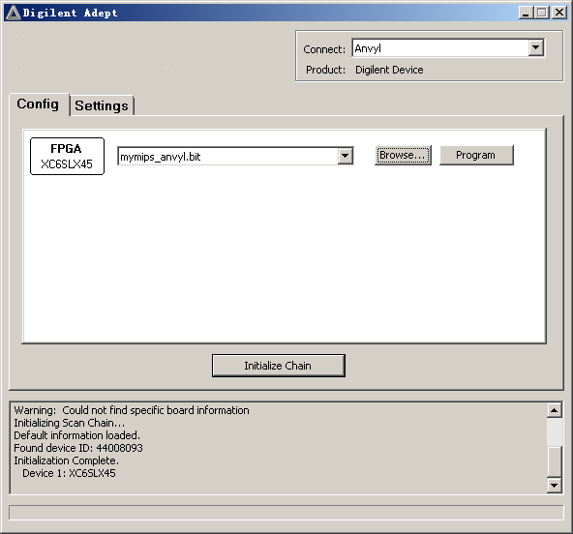
Figure 1. Digilent Adept Software

Select the bitfile provided at MIPS_Labs\Lab_1\mymips_anvyl.bit). Then click Program. It will begin running the pre-loaded program that displays incremented values on the LEDs.

Step 2. Compile the example program
Now compile the ReadSwitches example C program by opening a command shell. To do so, go to the Start menu, type in cmd.exe, and select 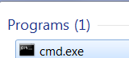. Or you can shift-right-click on an empty space on your screen and select "Open command window here". In the command shell, change to the Lab_1\C\ReadSwitches directory. For example, if MIPS_Labs is in C:\ type:

cd C:\MIPS_Labs\Lab_1\C\ReadSwitches

Compile the example C code by typing make at the prompt in the command window:

make

This runs the Makefile, which compiles the user code (found in main.c) with the boot code (found in boot.S). Open and view the Makefile using a text editor such as Notepad, Notepad++, or Wordpad. For future programs, any C program files can be placed under "CSOURCES="

CSOURCES= \
main.c

Below is a brief description of the main parts of the Makefile. The top part of the file gives the names and locations of the compiler tools (gcc, ld, objdump, etc.). These compiler tools are provided with Codescape. They are GNU tools targeted to the MIPS processor.

ifndef MIPS_ELF_ROOT
$(error MIPS_ELF_ROOT must be set to point to toolkit installation root)
endif

CC=mips-mti-elf-gcc
LD=mips-mti-elf-ld
OD=mips-mti-elf-objdump
OC=mips-mti-elf-objcopy
SZ=mips-mti-elf-size

The next part of the Makefile indicates the flags to use for compiling and loading the program.

CFLAGS = -O1 -g -EL -c -msoft-float -march=m14kc
LDFLAGS = -EL -msoft-float -march=m14kc -Wl,-Map=Program.map

For the C flags, -O1 says to use optimization level 1. You can change this to higher optimization levels as desired, for example optimization level 2 (-O2) or 3 (-O3). It is typically a good idea to debug your code using the lowest optimization level (0 or 1). Then, once your code is working, increase the optimization level to produce faster, denser code. –march=m14kc indicates to target the M14K MIPS microAptiv architecture, -msoft-float says that there is no floating-point unit and to use software floating point routines instead.

The LDFLAGS are used when creating the ELF file, which will provide the program code as well as information about how to load the program and data into the MIPS system's memory. Generally, the LDFLAGS indicate to not generate any floating point instructions (–msoftfloat) and to target the M14K MIPS architecture. The file indicated (Program.map) describes how and where the program, boot code, and data will be loaded into memory, according to the physical memory map shown in Lab 1. The rest of the LD flags (LDFLAGS += ...) indicate where to place the program, boot code, stack, etc. in memory.

The remainder of the Makefile describes how to compile the program and to clean the directory (i.e., remove files created during compilation). To clean the directory of files created during compilation, type the following at the command prompt:

make clean

If you just cleaned the directory, compile the program (main.c) again by typing make at the command prompt. Notice that at the end of compilation, the Makefile outputs the size of the executable, as shown in Figure 3.
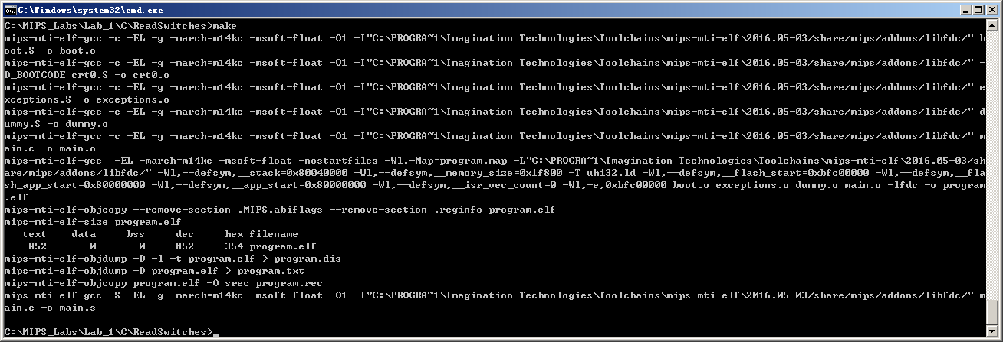
Figure 3. Command shell output of Makefile

The text (instructions) is 852 bytes, the data is 0 bytes and the bss segment (static data that should be initialized to 0) is 0 bytes for a total of 852 = 0x354 bytes. This fits easily within the MIPS memory space. However, you will want to keep your eye on these numbers for larger programs to make sure they fit within MIPS's physical memory.

Note that you can also obtain the size of the program by typing the following at the command line:
mips-mti-elf-size program.elf

You should now see the following files in the ReadSwitches directory:
- program.elf
- program.dis
- program.txt
- program.rec
- main.o

program.elf is the main output of compilation. It is the ELF (executable and linkable format) executable that you will use to load the program into the memory of the MIPS core.
program.dis is a disassembled version of the executable. It is basically a human-readable version of the ELF file that shows instruction addresses and instructions interspersed with the line numbers of the higher-level (assembly or C) source code.
program.txt is another human-readable version of the ELF file, but it is not interspersed with the source code information. It shows the memory addresses and corresponding instructions/data, including those memory addresses that should be initialized to 0.
program.rec is the motorola s-record format version of the instructions stored in memory.
main.o is the executable and linkable version of main.c.

Open program.dis using a text editor to see where the boot code and user code will be placed. The top of the file shows the boot code, starting at 0x9fc00000. Recall that this virtual address maps to physical address 0x1fc000000, which is the physical address of the first instruction fetched upon reset of the MIPS core.

Step 3. Load the C program onto the MIPS system using UART
Now that the example program is compiled, load it onto the MIPS core using the UART.

Downloading a program using the UART
The FPGA board can use the existing programming cable to download programs. Make sure the programming cable is connected between the FPGA board and your computer. Now, check which COM port is used by the programming cable by running the following batch file at the command prompt:
check_which_com_port_is_used.bat
The batch file is available in the MIPS_Labs\Lab_1 directory and can be run in that same directory. The COM port used by the cable will report as shown in Figure 4. Other ports will report that they are not in use or that it is an illegal device name. In this case, the cable is connected to COM port 6.
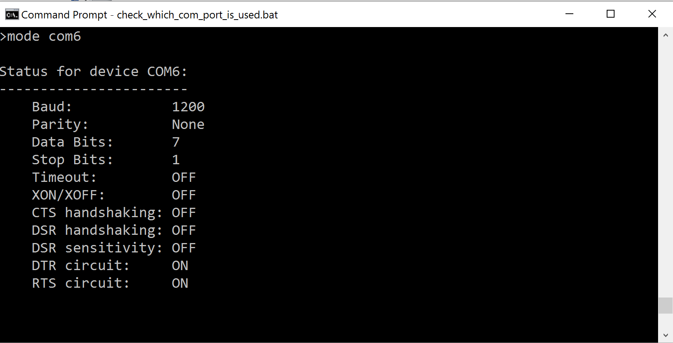
Figure 4. Checking which COM port is used by the programming cable

As another option, you can always use the Device Manager to check which COM port is connected to the FPGA board.

Now download the compiled program to the MIPS system. Make sure that the program is compiled (i.e., perform make in the program directory). Next, edit the upload_to_board_using_uart.bat script using an editor such as Notepad++. Change the a variable to the port used by the cable, in this example 6 (as shown in Figure 5).

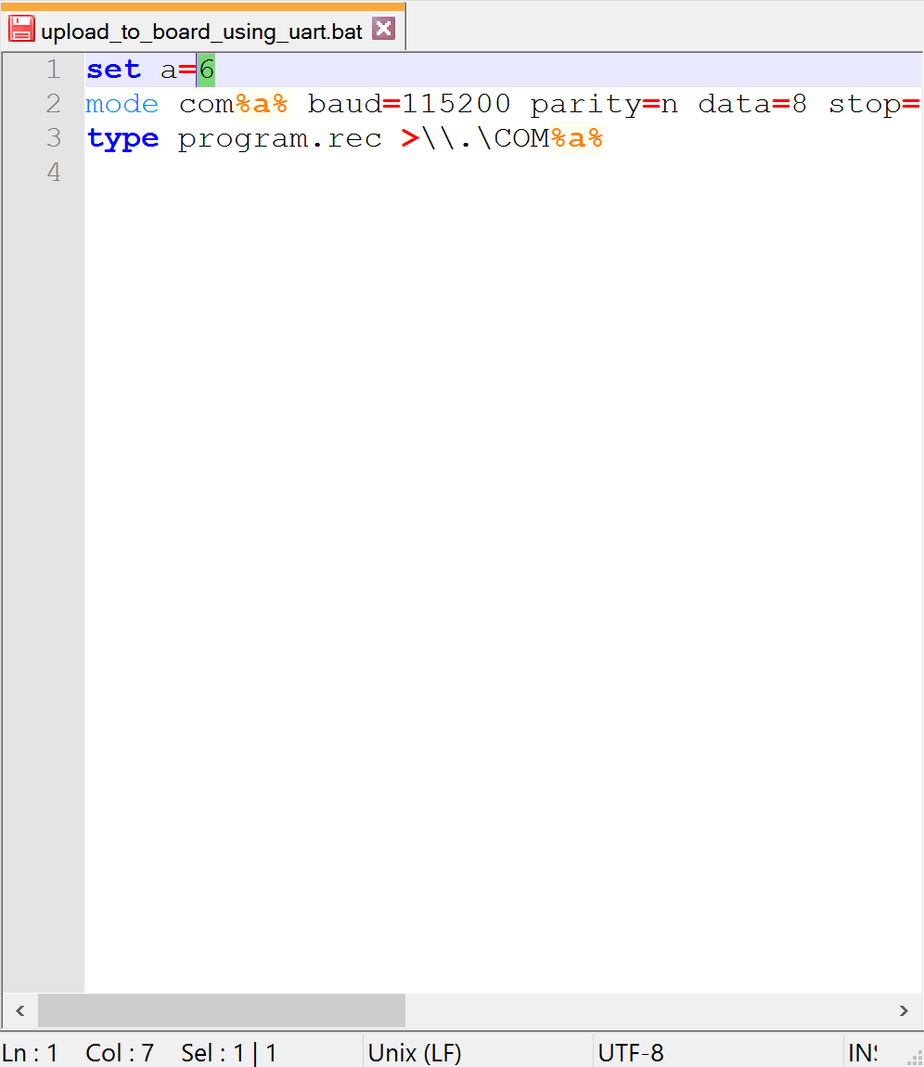
Figure 5. Changing COM port number in upload_to_board_using_uart.bat file

Now copy this file (upload_to_board_using_uart.bat) to the program directory, open a command shell and execute the file. For example, type the following two commands shell:
> cd C:\MIPS_Labs\Lab_1\C\ReadSwitches
> upload_to_board_using_uart.bat

You should now see the program running on the MIPS system on the FPGA board.

Fibonacci Numbers
Now you will write your own C program, compile it, and run it on MIPS. Create a program that will calculate and display the first 11 Fibonacci numbers on the LEDs. Each number in the Fibonacci series is the sum of the previous two numbers. Table 1 lists the first few numbers in the series.
Table 1: Fibonacci Series
n | 1 | 2 | 3 | 4 | 5 | 6 | 7 | 8 | 9 | 10 | 11 | …
fib(n) | 1 | 1 | 2 | 3 | 5 | 8 | 13 | 21 | 34 | 55 | 89 | …
fib(n) | 0x1 | 0x1 | 0x2 | 0x3 | 0x5 | 0x8 | 0xd | 0x15 | 0x22 | 0x37 | 0x59

These values are useful when writing a loop to compute fib(n) for all non-negative values of n.
Make a copy of the Lab_1\C\ReadSwitches folder and rename the new folder Fibonacci. Write your program in the main.c file in that folder. Your program should compute the Fibonacci numbers for n = 1…11 and output each Fibonacci number to the LEDs. The LEDs should display the Fibonacci numbers in binary, with a delay between each number so that they are viewable.
Once you have finished writing your program, use the make command to compile it. If there are any errors, fix them and recompile.
After your Fibonacci program compiles without errors, load it onto the MIPS core using the UART interface.

